Assignment1 - Source code

<?php

    $total = 0;

    for ($x = 0; $x <= 50; $x+=1) {

        echo "The number is: $x \n";

        $total += $x;

    }

    echo "The total number of 1 to 50 is $total.";

 ?>

Assignment1 – Output

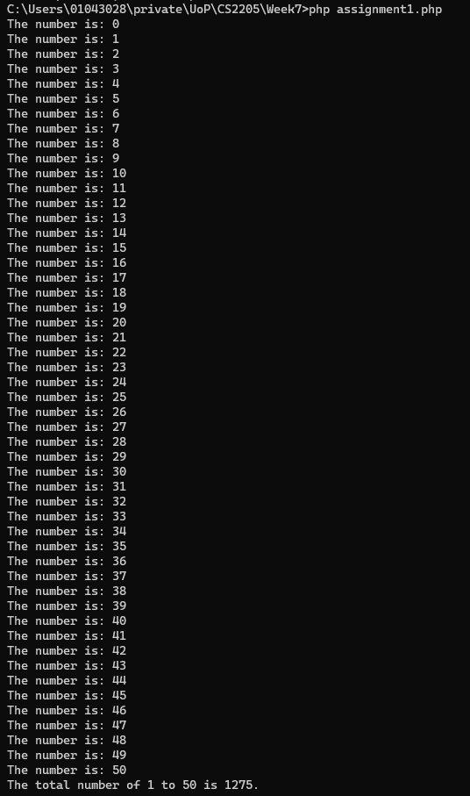

Assignment2 – Source code

<?php

    $age = $argv[1]; //give your age as an command line argument. The first element of array is the php file itself, so assign the second element as an input.

    if ($age < 19){

        echo "Your age is $age, which does not meet the criteria.";

    }else{

        echo "Okay, you are eligible to vote!";

    }

?>

Assignment2 – Output

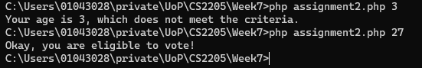

Assignment3 – Source code

<?php

   $num = $argv[1]; //give your age as an command line argument. The first element of array is the php file itself, so assign the second element as an input.

   if (is_numeric($num)){

        if ($num == 1){

            echo "Your input is $num, which is not prime.";

            exit;

        }

        for ($i = 2; $i <= $num/2; $i++){

            if ($num % $i == 0)

            echo "Your input is $num, which is not prime.";

            exit;

        }

        echo "Your input is $num, which is prime.";

        exit;

    }else{

        echo "Your input is $num, which is not integer type. Please input a valid value.";

        exit;

    }

?>

Assignment3 – Output

